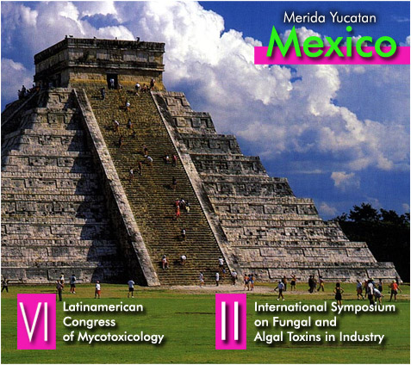

1. The Organization Committee needs that each participant fulfills the Official Form for Payment and return it by e-mail:
mptoxins2009@ibiologia.unam.mx

2. The last day to pay the Registration fee is Jan. 28 th, 2010, later the price increases.

3. The hotel needs the payment of the first night to book the room.

4. If the participants do not show in the hotel the first night, without cancellation 60 days previously, the first night will be charged together with taxes.

5. Official Travel Agency and Tour operador: Miss Norbé Pacheco. Turitransmerida
tel: + 52 (999 )923 – 9351 and 930-9224 and Tel and fax: + 52 (999) 924 - 1199 and 928-1871 npm_20@hotmail.com

OFFICIAL FORM FOR PAYMENT

Name of participant:

Deposits in USD or equivalent in Mexican pesos to: UNIVERSIDAD NACIONAL AUTÓNOMA DE MÉXICO

Bank in Mexico for Deposits and Transfers:
BBVA Bancomer
Account: 00446634494
CLABE: 012 180 004466344942
Branch: 7684
Place: 001 Ciudad de México.
Address: Avenida Coyoacán N° 612. Col. Del Valle. CP.03100 Mexico D.F.

Deposits in USD from foreign countries to: UNIVERSIDAD NACIONAL AUTONOMA DE MEXICO

Bank: J.P. Morgan Chase Bank
Account: 001-01693118
Address: P.O. Box 2558 Main Street Houston Texas, United States of America.
Telephone: 001-713-216-6324
SWIFT: CHA SUS33
ABA: 021000021
PLEASE SEND A COPY OF THE VAUCHER OF YOUR DEPOSIT AND THE FULFILLED OFFICIAL FORM OF PAYMENT ORDER TO:
DR. MAGDA CARVAJAL.
FAX: + 5255- 5550-1760 OR BY E-MAIL: mptoxins2009@ibiologia.unam.mx
TO FOLLOW YOUR PAYMENT AND GIVE YOU A GOOD SERVICE.
DETAILED PAYMENTS
Items | Includes | Last  payment date | Cost in USD | Total by participant
1. Pre-congress workshops
a. HCCP in a food industry (June 26) |  | Jan 28, 2010 | 150
b. Mycotoxins - Rapid methods.  (June 26) |  | Jan 28, 2010 | 150
c. Phycotoxins. (June 26 - 27) |  | Jan 28, 2010 | 300
2. Registration
Student |  |  | 300 USD till Jan 28, 2010;  350 USD afterwards
Normal participant |  |  | 500 USD till Jan 28, 2010;  600USD afterwards
Member of SLAM  (with paid annual fee) |  |  | 450 till Jan 28, 2010;  500 USD afterwards.
Stand in the Technological Exhibition |  |  | 4000 USD till Jan 28, 2010;  4200 USD afterwards
3. Hotel payment | The Hotel needs the payment of the first night to book the room.
Single ( )  or double ( ) room. |  |  | $ 85 USD / night
Number of nights
Taxes (IVA 16%) |  |  | $13.60 USD
Room waitress |  |  | $ 2.30 USD per room each day
Bell boy |  |  | $ 2.70 USD per person twice  (entrance and exit)
Total for night |  |  | $ 110.05 USD taxes and tips included
4. Welcome Ceremony |  | June 27, 2010 | Free
5. Banquet
Hacienda Temozon (June 30, 2010) + transportation |  | June 28, 2010 | 80
6. Transportation | Van |  | 55
Airport- Hotel Fiesta Americana | Car |  | 14
Hotel Fiesta Americana- Airport | Car |  | 14
7.Tours  (Check details of tours in web site mptoxins2009@ibiologia.unam.mx) | You can pay your tours directly to the travel Agency:  Miss Norbé Pacheco Turitransmerida  tel: +52(999)923-9351and 930-9224  and Tel and fax: +52(999)924-1199 and 928-1871 npm_20@hotmail.com

